##### A PROJECT REPORT

**ON**

Logistics Website

##### Submitted by

**Mr. Shivtej Shankar Kadam Ms. Sushmita Bhalchandra Juikar Ms. Shivani Shankar Kadam Ms. Sanjivani Bhalchandra Juikar**

**In partial fulfilment of the requirement for the project the award of the Diploma in**

Computer engineering

Under the Guidance of

##### Prof. S .S .BHAMRE

**Department of Computer Engineering**

### GOVERNMENT POLYTECHNIC PEN

**(2020-2021)**

Certificate

This is to certify that, the project work entitled ‘**’Logistic Management Website** ‘’ has been duly completed by

In a satisfactory manner under my guidance as a fulfilment for the award of Diploma in Computer Engineering of

**MAHARASHTRA STATE BOARD OF TECHNICAL EDUCATION MUMBAI.**



|  |  |
| --- | --- |
| **Prof. V. Kharmate** | **Prof. V. Kharmate** |
| Head of the Department | Project Guide |
| Department of Computer Engineering | Department of Computer Engineering |
| Govt. Polytechnic, pen | Govt. Polytechnic, pen |

###### Prof. S . S. Bhamre

PRINCIPAL

### GOVERNMENT POLYTECHNIC PEN

**EXAMINAR’S CERTIFICATE**

This is to certify that the project work of the Diploma Course in Computer Engineering, at

**GOVERNMENT POLYTECHNIC PEN**

has been duly completed by

**Mr. Shivtej Shankar Kadam Ms. Sushmita Bhalchandra Juikar Ms. Shivani Shankar Kadam Ms. Sanjivani Bhalchandra Juikar**

Under

MAHARASHTRA STATE BOARD OF TECHNICAL EDUCATION MUMBAI

For as Year 2020-2021

Were Examined in the project entitled

“Logistics Website” On Date 17 / 06 / 2021

Signature Signature

Internal Examiner External Examiner



**DEPARTMENT OF COMPUTER ENGINEERING**

### GOVERNMENT POLYTECHNIC PEN

#### Acknowledgement

It is indeed a great feeling of pleasure and pride to present the project on **Logistic Website** at Government Polytechnic Pen .

Looking back on the complement of our project work we realize how impossible it would have been for us to achieve success by our own.

With the deep sense of gratitude & profound respect, I acknowledge my oblivion to my guide **Prof. V. Kharmate** for the valuable guidance & timely inspiration for providing all facilities needed for successful completion.

Last but not the least. We also greatly acknowledge to our HOD **Prof. V. Kharmate** and also all lecture of Computer Department and all those people to help us directly or indirectly complete our project successfully.

“**Make it simple but significant**.”

**Project Team…**

|  |  |
| --- | --- |
| Mr. Shivtej S. Kadam | Ms. Sushmita B. Juikar |
| Ms. Shivani S. Kadam | Ms. Sanjivani B. Juikar |

##### Content

|  |  |
| --- | --- |
| Chapter No. | **Title** |
|  | **Abstract** |
|  | **List of Screenshots** |
| **1** | **Introduction** |
|  | **1.1** Introduction to the Project |
|  | **1.2** Purpose of the Project |
|  | **1.3** Problems in Exiting System |
|  | **1.4** Solution of These Problem |
| **2** | **Literature Review** |
|  | **2.1** Introduction |
|  | **2.2** Existing System |
|  | **2.3** Proposed System |
| **3** | **System Analysis** |
|  | **3.1** Introduction |
|  | 3.2 Study of the System |
|  | **3.3** Number of Modules |
|  | **3.4** Hardware and Software Requirement |
| **4** | **Testing** |
| **5** | **Future Scope** |
| 6 | **Implementation** |
| **7** | **Conclusion** |
| **8** | **Reference** |

**List of Figure**

|  |  |  |
| --- | --- | --- |
| **Diagram No.** | **Diagram Name** | **Page No.** |
| **1** | Data Flow Diagram | 15 |
| **2** | ER Diagram | 17 |
| **3** | Class Diagram | 18 |
| **4** | UseCase Diagram | 19 |

**LIST OF SCREENSHORTS**

|  |  |
| --- | --- |
| Sr No. | **Title** |
| **1** | **Login Screen** |
| **2** | **Sign Up /Create Account Screen** |
| **3** | **Home Screen** |
| **4** | **Activity Screen** |
| **5** | **Service Providers Screen** |



# ABSTRACT

In the contemporary global business markets environment, when the business markets are getting more and more commercial, there are growing demand for effective management of material flows. The effectivity and effectiveness of planning, management and control the material flows across an industrial company and its distribution networks, represents one of the main pillar regarding the high level of competitive advantage within the frame of supply chains. Thus, the company information management system design should have also included a module of integrated logistics management system to ensure required level of material flow management effectivity and effectiveness.

Logistics is part of supply chain management in planning, implementing, and controlling the flow and storage of goods, information, and services effectively and efficiently from point of origin to point of destination in accordance with consumer demand. By using information and communication technologies, the public can provide information on the logistics so that the information concerning about logistics in India knew about the problems that occurred. Logistics is generally the detailed organization and implementation of a complex operation. In a general business sense, logistics is the management of the flow of things between the point of origin and the point of consumption in order to meet requirements of customers or corporations.



Chapter no: -1

INTRODUCTION

###### A.1. INTRODUCTION OF THE PROJECT

Logistics is the flow of goods and services. It includes the movement and storage of raw materials, work-in-process inventory, and finished goods from point of origin to point of consumption. The management of the supply chain is really a challenging task, if it had automated software to keep monitoring the supply chain even from the origin of raw materials, transportation, processing, production of the finished goods, quality analysis and delivering it would had been really helpful and make the entire production process really easy. The java based application that was created has the capability of procurement of data that is, it can all by itself acquire the data like the requirement of the end customers, ordering the amount of the raw materials, manufacturing time line, quality analysis, shipment delivery including tracking, customer feedback. The project involved some programming languages like Java, HTML, CSS, Java Script, and Bootstrap. It needed a server.

The individual who needs the products goes onto the website of the supplier and places the order; this order is forwarded to the manager of the supplier via a secured channel which involves a bunch of authentications and security layers. The supplier or the corresponding manager then grants permission to the web based application to go ahead and place an order for the raw materials, then the processes of manufacturing that are applicable for the 9 production are suggested and they can be selected by the manager, quality analysis is also a capability of the application, delivery of the product to the customer and the process of taking feedback from the customer is all part of the functions of the website application.

**1.2. PURPOSE OF THE PROJECT**

Logistics companies plan, implement, and control the movement and storage of goods, services, or information within a supply chain and between the points of origin and consumption. Various logistics companies handle some or all of these supply chain functions, depending on a client's logistical needs.

##### PROBLEM IN EXISTING SYSTEM

* + We create logistics website it reduce manual work.
  + In current websites of logistics requests are not work properly.
  + We overcome problems and also added new features in website.(additional information of service provider )
  + We create this website robust and secure.
  + News, event, order and all related information we can find out in website.



Chapter no: - 2

## LITERATURE REVIEW

##### INTRODUCTION

The individual who needs the products goes onto the website of the supplier and places the order; this order is forwarded to the manager of the supplier via a secured channel which involves a bunch of authentications and security layers. The supplier or the corresponding manager then grants permission to the web based application to go ahead and place an order for the raw materials, then the processes of manufacturing that are applicable for the 9 production are suggested and they can be selected by the manager, quality analysis is also a capability of the application, delivery of the product to the customer and the process of taking feedback from the customer is all part of the functions of the website application.

##### EXISTING SYSTEM

Before presiding with the design and implementation of this project, we have studied existing systems and also studied other transport website. This study helps us lot to know the various features of transport website. We have studied each system and notice some special features and some special drawback of them. The existing system is very time consuming. The existing system is not properly arranged. In existing system vendor information not display correctly. The existing system not provides all data. The existing system does not display information of members properly.

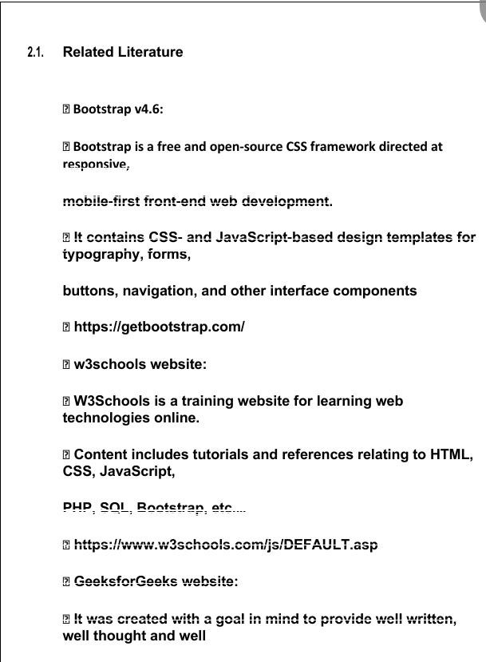



Chapter no: -3

## SYSTEM ANALYSIS

###### STUDY OF THE SYSTEM

Before presiding with the design and implementation of this project, we have studied existing systems and also studied other transport website. This study helps us lot to know the various features of transport website. We have studied each system and notice some special features and some special drawback of them. The existing system is very time consuming. The existing system is not properly arranged. In existing system vendor information not display correctly. The existing system not provides all data. The existing system does not display information of members properly.

###### NUMBER OF MODULES

* + - Vendor
    - Service Provider
    - Logistics Website
  1. **Use Case Diagram**

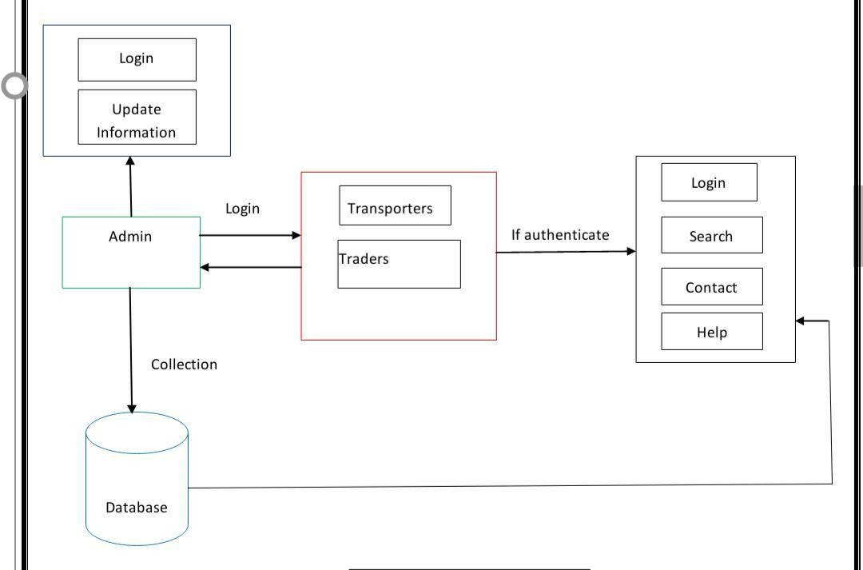

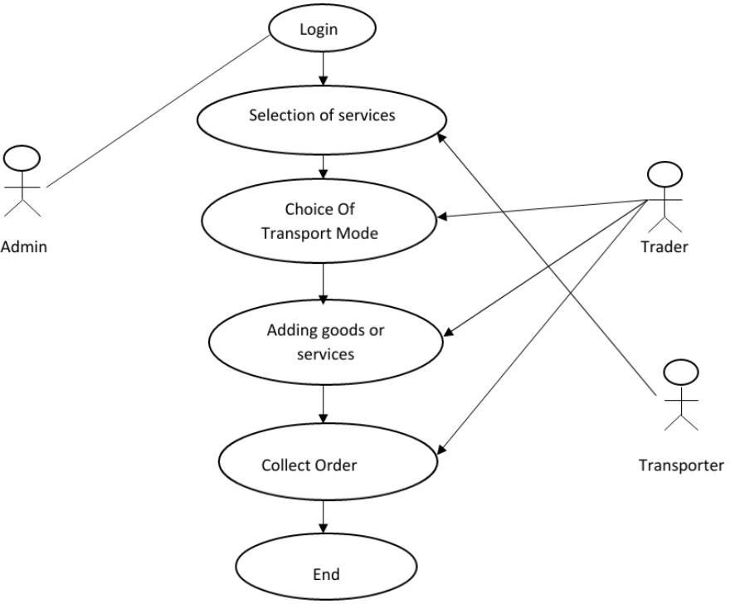

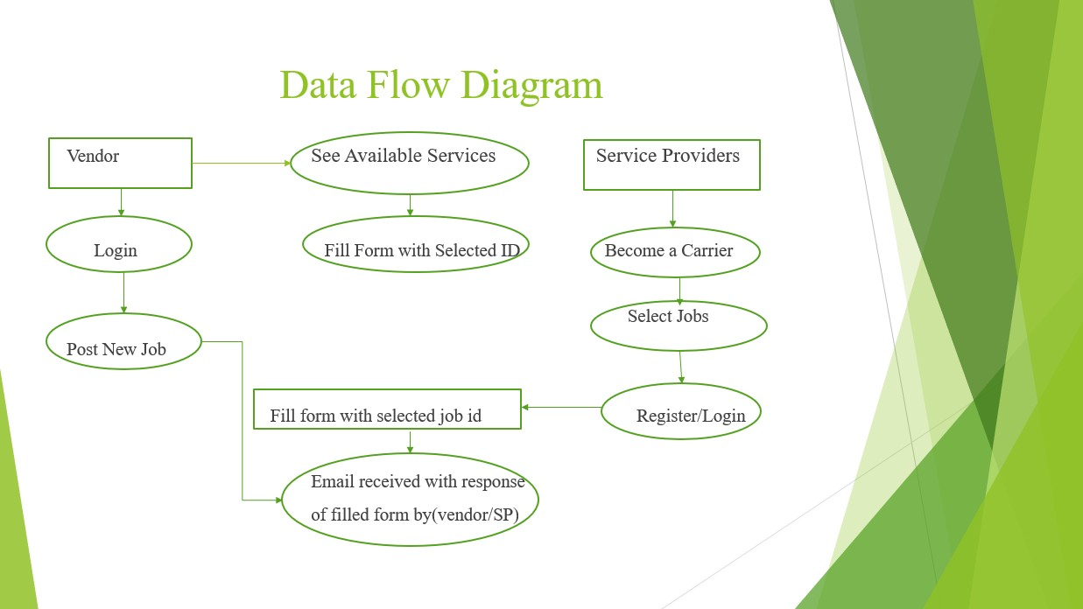

* 1. **HARDWARE AND SOFTWARE REQUIREMENT**

|  |  |  |
| --- | --- | --- |
| **SR NO.** | **REQUIREMENT** | **SPECTIFICATION** |
| 1. | Laptop | Lenovo s145 |
| **SOFTWARE** | | |
| 1. | Visual Studio Code (Editor) | 1.51.1 |
| 2. | XAMPP | - |
| 3. | Google Chrome | - |
| 4. | Word | 2019 |
| 5. | Power Point | 2019 |



Chapter no: -4

## TESTING

###### TESTING:

Software is tested from different perspectives:

* + - White box test.
    - Black box test

White box Test:

White box tests focus on the program control structure, internal program logic is exercised using this technique.

Black box Test:

Black box testing is software requirements are exercised and derive sets of inputs conditions that will fully exercise all functional requirements for a program this testing is also called “behavioral testing”.

Once code has been generated, program testing begins. The testing process focuses on the logical internals of the software, ensuring that all statements have been tested and on the functional externals; that is, concluding test to uncover errors and ensure that defined input will procedure actual results that agree with required results.

###### UNIT TESTING:

* + - * It is a method of testing that verifies the individual units of source code.
      * A unit is the smallest testable part of an application.
      * This is also known as “module testing”.
      * After writing code of each module like design of game board, rolling of dice, movement of dice and user interface, we separately checked whether the result generated is correct or not.
      * We have applied these testing on a set of dummy moves for testing purposes.
      * Each module is tested a large number of times till the integration is done.

###### INTEGRATION TESTING:

* + - * ‘Integration Testing’ (sometimes called Integration and Testing, abbreviated I&T) is the phase of software testing in which individual software modules are combined and tested as a group.
      * We have taken input modules which have been unit tested and grouped them in large scale tests as defined in an integration test plan to those aggregates, and then the output is obtained as an integrated system, ready for system testing.

###### SYSTEM TESTING:

* + - * System testing of software or hardware is testing conducted on a complete, integrated system to evaluate the system’s compliance with its specified requirements. System testing falls within the scope of black-box testing, and as such, should require no knowledge of the inner design of the code or logic.
      * Effort was done to maximize the number of iterations of all modules testing to remove all the errors.

###### VALIDATION TESTING:

* + - * After integration testing and system testing, software is completely assembled as a package, interfacing errors has been uncovered and corrected ➢ A final series of software tests, validation begins.

###### RECOVERY TESTING:

* + - * In software testing, we have preceded the recovery testing to test how well the software is able to recover from crashes, hardware failures and other similar problems.
      * We have practically performed this testing by running our software on the systems heavily loaded with running processes, a desktop running on UPS and a laptop running on battery power. The result was success in every case.

33

6.1 Test Cases

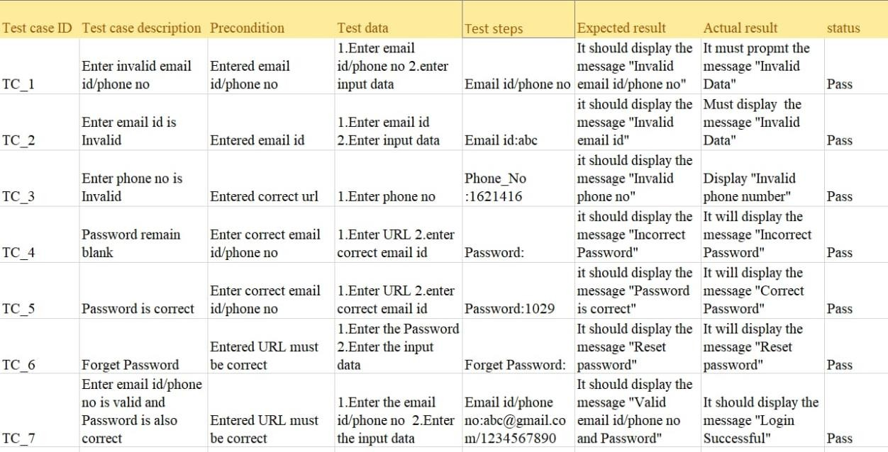

* 1. **Applications**
     + User friendly- User friendly describe a hardware device or software interface that is easy to use .It is friendly to the user, meaning it is not difficult to learn or understand
     + Responsive design- Responsive design is an approach to web age creation that makes use of flexible layouts, flexible images and cascading style sheet media queries .The goal of Responsive design is to build web pages that detect the visitors screen size and orientation and change the layout accordingly
     + Quality work- Quality work means consistently achieving expectation while having a positive, ethical working environment .It means putting your best foot forward every day to ensure the success of the organization
     + Time saving- reducing the amount of time needed to do something he had no idea this time saving idea would turn into a profitable business.
     + Computerized work- A Computerized system, process, or business is one which the work is done by computer.



Chapter no: -5

## FUTURE SCOPE

###### Future scope

1. Access information.
2. Vendor can give feedback on website.
3. An admin login should be present who can read as well as remove an upload.
4. vendor is able to see available service providers on website.



Chapter no: -6

## IMPLEMENTATION

##### IMPLEMENTATION

* + A join in DFD means that exactly the same data comes from any one or more different processes data store or sink to a common location.
  + A data flow cannot directly back to the same process it leads. There must be at one other process that handles the data flow produce some other data flow returns the original data into the beginning process.
  + A Data flow to a data store means update (delete or change).
  + A data flow from a data store means retrieve or use.
    - First We create basic home page with four menu bars
  + Registration and Login page
    - reate a form where vendor can post a new job
    - We made that jon available to see for service provider
    - At menu bar we add service providers section where the uploaded information by service provider is shown to vendor
    - We also created about us page
  + Contact page For any query.

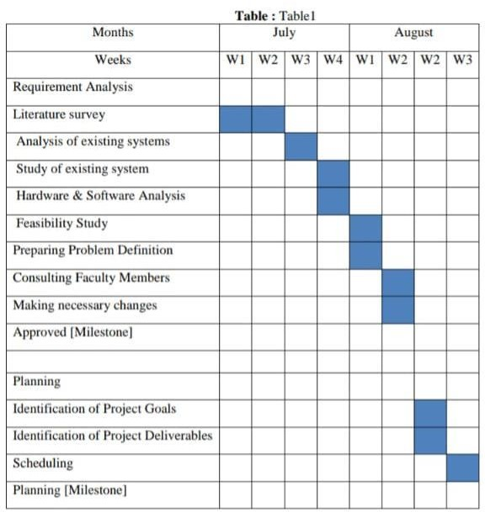

* 1. E-R DIAGRAMS
     + The relation upon the system is structured through a conceptual ER- Diagram, which not only specifies the existential entities but also the

standard relations through which the system exits and the cardinalities that are necessary for the system state continue.

* + - The entity Relationship Diagram (ERD) depicts the relationship between the data objects. The ERD is the notation that is used to conduct the date modeling activity the attributes of each data object noted is the ERD can be described resign a data object description.
    - The set of primary components that are identified by the ERD are
    - Data object
    - Relationships
    - Attributes
    - Various types of indicators

The primary purpose of the ERD is to represent data objects and their relationships

##### Home Screen

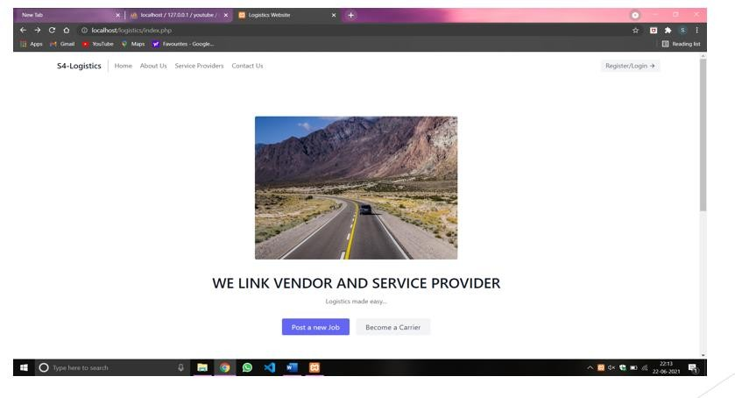

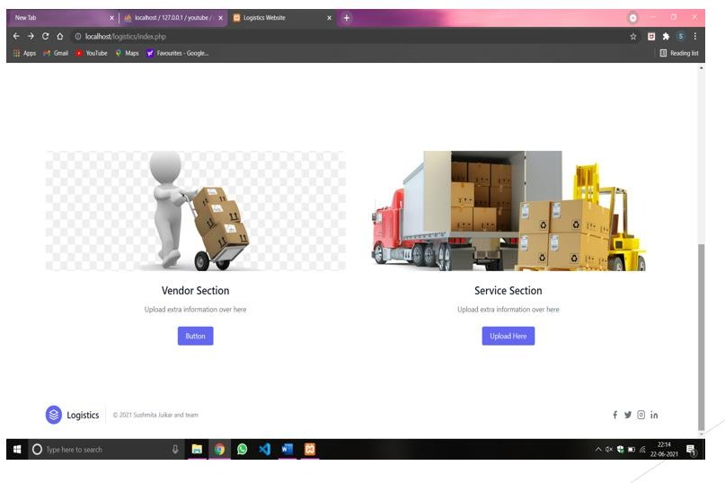

**Registration and Login Page**

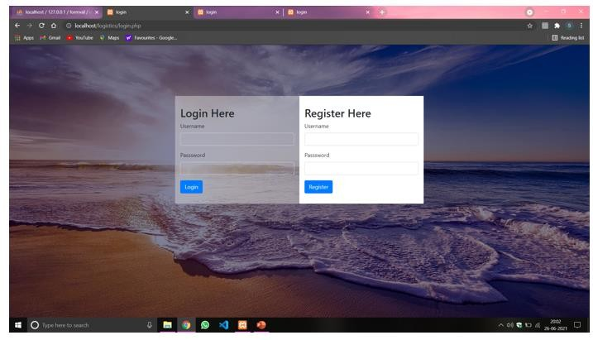

##### Post Jobs For Vendors

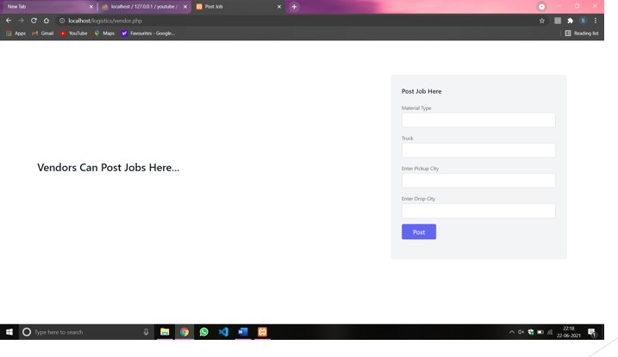

**Available Jobs Are Shown Here**

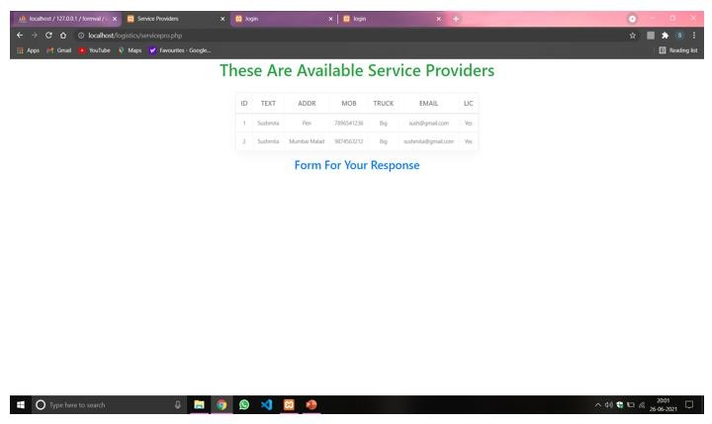

##### Service Providers (Extra Information upload)

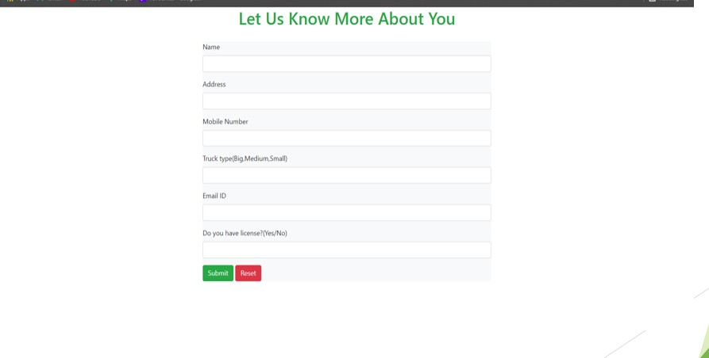

**Available Jobs for Service Providers**

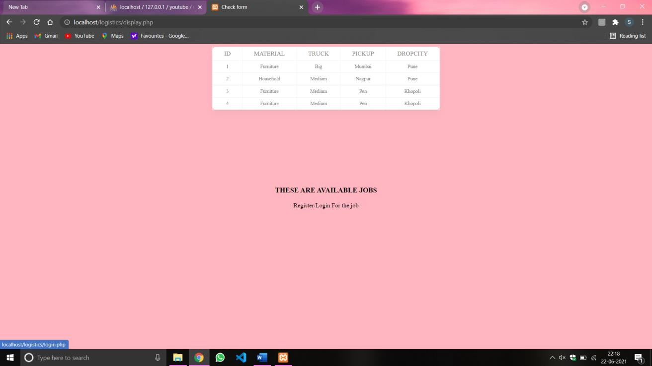

##### Responsiveness

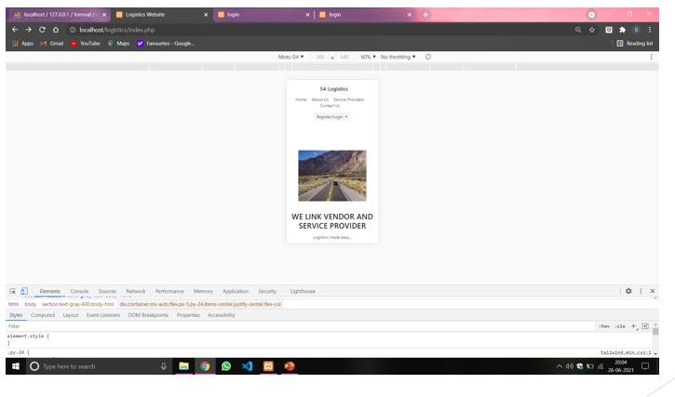

**Final Response Of Vendors**

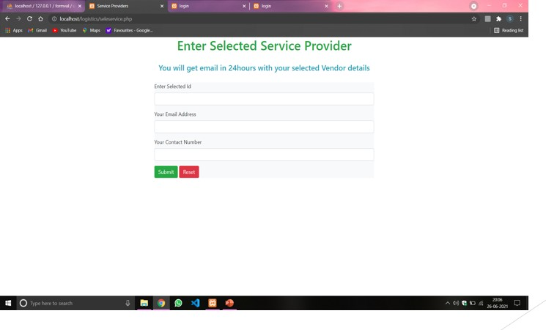



Chapter no: -7

## CONCLUSION

##### 8.1 CONCLUSION

Thus We have Successfully Created Website For Logistic Management where vendor can find available service providers and service providers can find job for them.



Chapter no: - 8

# REFERENCE

##### REFERENCES WEBSITES

* + 1. <http://trophyexpress.com/>

This is an existing website. We refer to this website to finding out bugs and to collect transport related information.

* + 1. https://[www.w3schools.com :](http://www.w3schools.com/)

By using this website we learn all tags and functionalities.

* + 1. https://studylink.com/study/degrees/web-development

By using this website we learn Web design and development incorporates both the creative design and back-end building of a website, and is a rising industry due to the popularity of

the online world.

* + 1. https://drexel.edu/

This is another college website. We study the design of this website; the structure of this website is too good and attractive so we are referring to this website.

* + 1. https://[www.learn-html.org/](http://www.learn-html.org/)

By using this website we learn how to use of html tags and functionalities; we also learned about how to create webpage and webpage menu.

* + 1. https://[www.w3.org/Style/CSS/learning.en.html](http://www.w3.org/Style/CSS/learning.en.html)

By using this website we learn how to webpage more attractive.